**LAB ASSIGNMENT-3**

**Screenshots**

**Login page:**

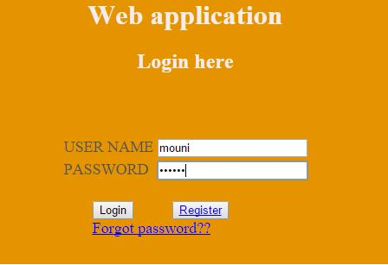

**Registration page:**

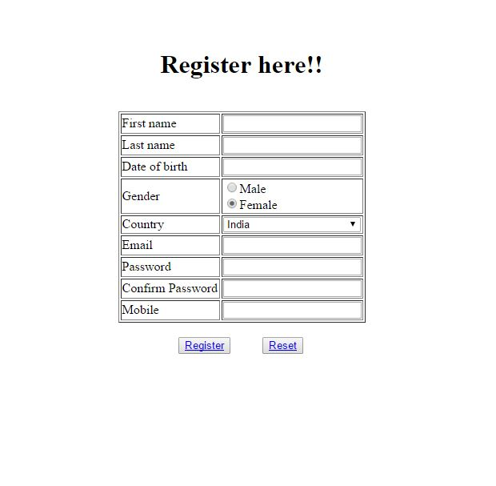

**Home page:**

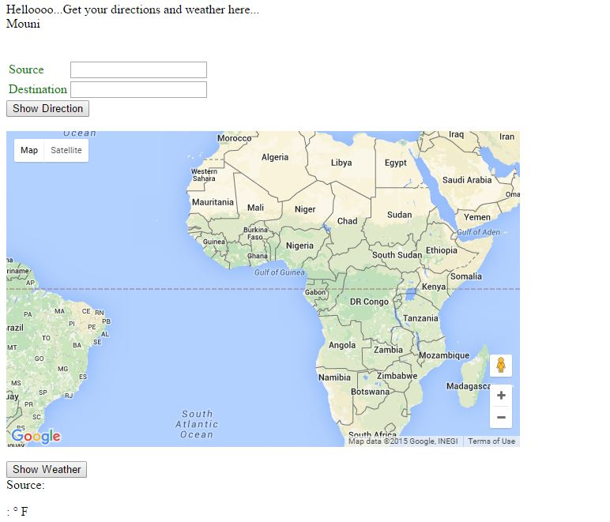

**Home page showing directions:**

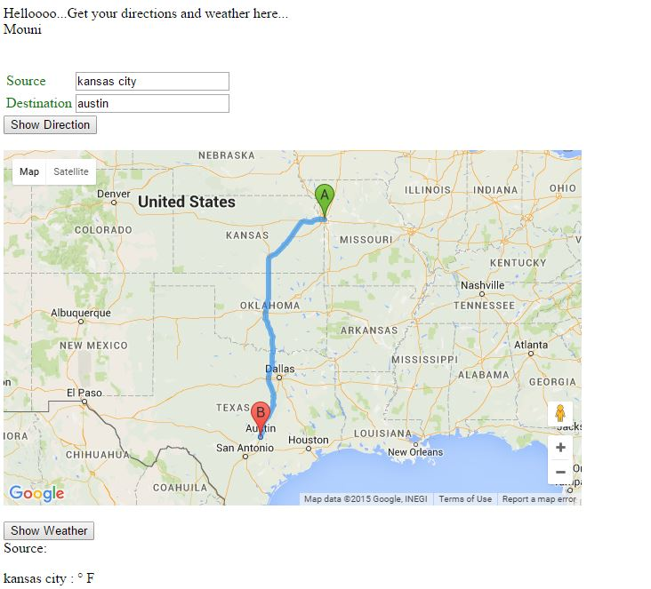

**Home page showing weather at source and destination:**

